# Model Conversion Process

Once the model is in blender:

* Save the blender file with the textures and **then** assign a texture to the object parts so the paths are relative
* After assigning the texture, under the image options page with the object material selected set coordintes to **UV** and layer to the image name. Without selecting the layer and UV coordinates the texture will not appear at all or appear incorrectly.

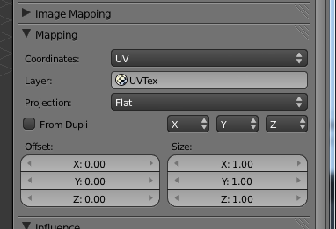

* To create multiple animations you should rename and create multiple actions by first selecting dope sheet and changing the dropdown to “Action Editor”. If you need to delete an action you have to deselect the “F” button **then** click the ‘X’, then save and reopen the .blend file. If you export before saving and reopening the “deleted” animations are also exported. Actions appear to be exported in the order they appear in the action dropdown.
* Export as **FBX** format then drop the model onto ModelConverter.exe found in Program Files/SCE/PSS/tools/ModelConverter. It will output an mdx file with the same name as the input file in the same directory. Copy and paste it to the project folder.
* When adding an mdx file to the project, right click it open the properties and set “Build Action” to “Content”